I1_10_cameras_grid100.csv

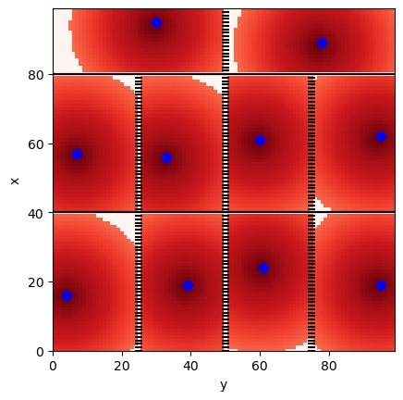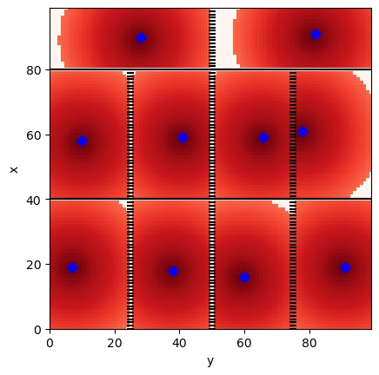

I2_5_cameras_grid200.csv

I3-5_cameras_grid100.csv

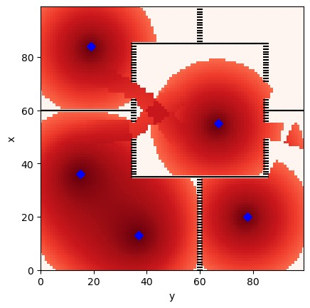

I4_5_cameras_grid100.csv

I5_5_cameras_grid100.csv

